Summary of MB analysis
January 2, 2014

Summary:

- We examined studies in the soil respiration database (SRDB) which reported annual soil respiration (SR) as well as how instantaneous SR varied with temperature.
- Data were joined with global climate data set of air temperature, precipitation, and Palmer Drought Severity Index (PDSI).
- Following Bahn et al. (2010) we estimated annual SR from SR at mean annual air temperature.
- Data now include all studies published through 2012 (n=~464), and cover the global climate space reasonably well.
- The Bahn et al. relationship predicted annual soil respiration extremely well (i.e. slope=1 and intercept=0 comparing observed and inferred annual SR), although with a fair amount of explained variability.
- There was no difference between heterotrophic- and autotrophic-dominated sites (but small N).
- Studies whose measurements covered less of the year, or located in regions with temperature of precipitation variability, were more likely to diverge from this relationship.
- Differences between the 0.5° climate data used and site-specific conditions increased variability significantly.
- We saw no effect of max PDSI (i.e. drought conditions).

Dataset and climate coverage. Depending on how tightly we constrain it, there are ~464 observations.

Figure A. Comparison of SRDB data (colored points) with global climate data set (grey background; darker squares mean more grid cells).
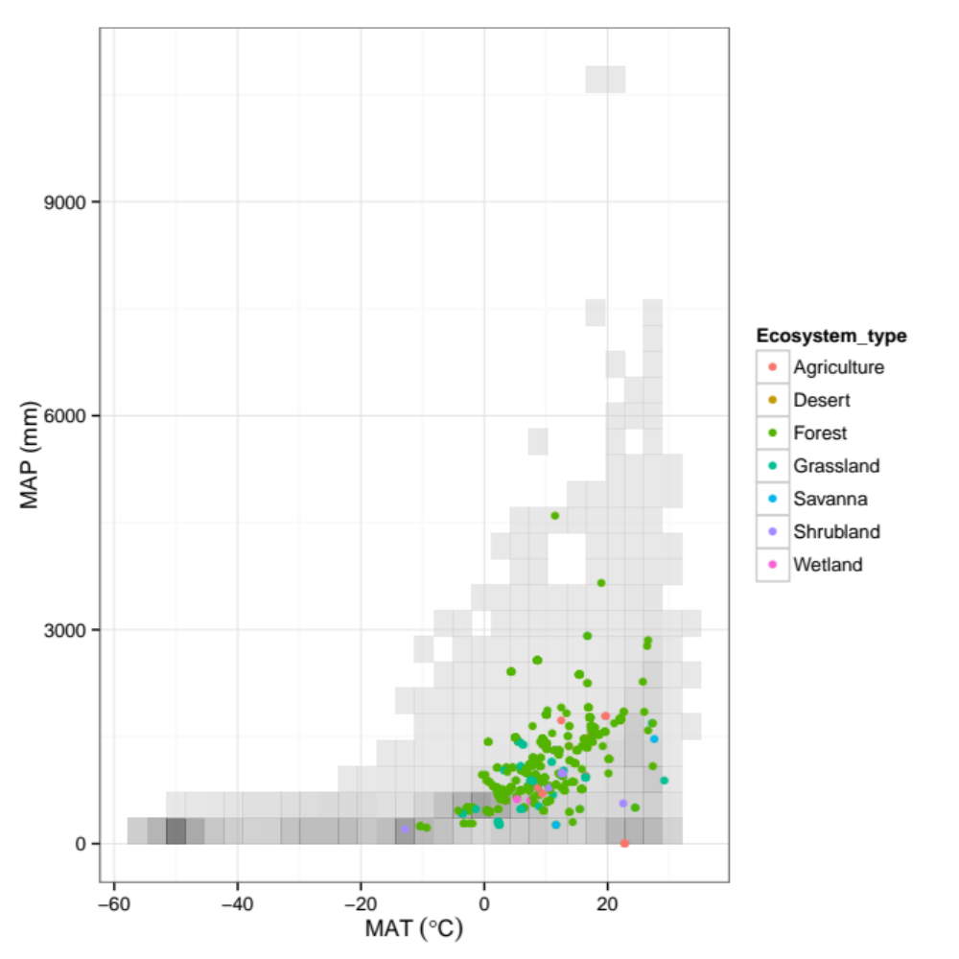

How well does the Bahn et al. (2010) equation predict annual SR?

(All models fit after eliminating influential outliers, observations for which the temp-SR relationship didn’t encompass MAT, and observations where MAT diverged significantly from global climate data set.)

Thu Jan 2 09:39:14 2014 Model summary:

Call:
lm(formula = Rs_annual_bahn ~ Rs_annual, data = sdata)

Residuals:
Min 1Q Median 3Q Max
-784.07 -148.64 4.04 147.52 1116.62

Coefficients:
Estimate Std. Error t value Pr(>|t|)
(Intercept) -37.40170 29.38141 -1.273 0.204
Rs_annual 1.01410 0.03248 31.222 <2e-16 ***
---
Signif. codes: 0 ‘***’ 0.001 ‘**’ 0.01 ‘*’ 0.05 ‘.’ 0.1 ‘ ’ 1

Residual standard error: 268.3 on 462 degrees of freedom
Multiple R-squared: 0.6785, Adjusted R-squared: 0.6778
F-statistic: 974.8 on 1 and 462 DF, p-value: < 2.2e-16

Thu Jan 2 09:39:14 2014 Test H0 of intercept=0: p-value = 0.2036684
Thu Jan 2 09:39:14 2014 Test H0 of slope=1: p-value = 0.6643781

Answer: Extremely well! The relationship between predicted SR (via SR @MAT) and reported annual SR is 1:1, with a slope=1 and intercept=0 (within statistical significance). There is lots of unexplained variability, with R²=0.68 and RSE of 268 g C m⁻² yr⁻¹.

This is visualized on the next page.
Figure B. Comparison between reported SR and SR inferred by Bahn et al. (2010) method. Dashed line is 1:1. Fitted solid line is surrounded by grey model error. Horizontal error bars show error (typically plot-to-plot), when reported by individual studies.
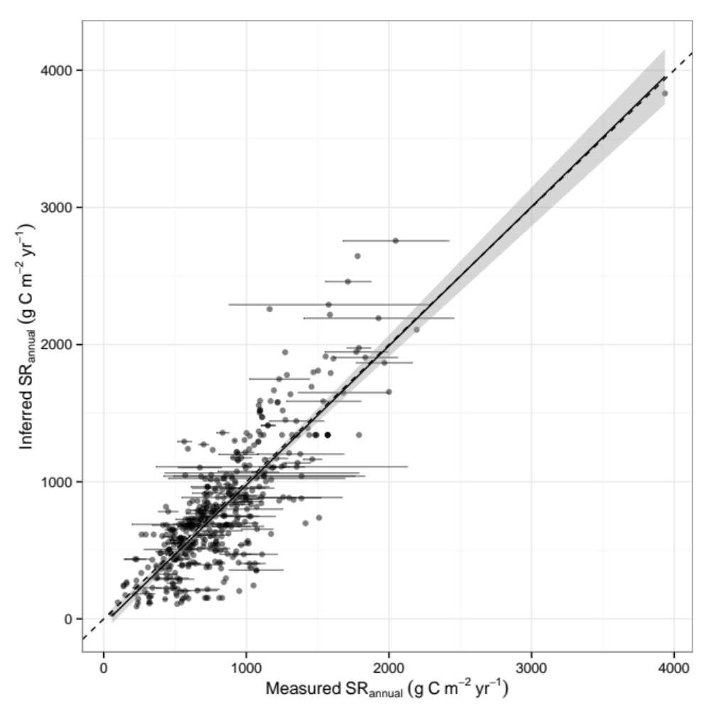

Is there a difference between heterotrophic- and autotrophic-dominated sites?

Not many data (82 data points reporting SR as well as RH and RA), and no, there’s no statistical difference between these sites:

Estimate Std. Error t value Pr(>|t|)
(Intercept) 243.31 58.47 4.161 7.92e-05 ***
Rs_TAIR 323.13 37.16 8.695 3.49e-13 ***
RC_annual > 0.5TRUE 126.60 96.14 1.317 0.192
Rs_TAIR:RC_annual > 0.5TRUE -13.35 53.82 -0.248 0.805

Figure C. Difference between RA-dominated sites (RC_annual>0.5 is TRUE) and RH-dominated ones (RC_annual>0.5 is FALSE).

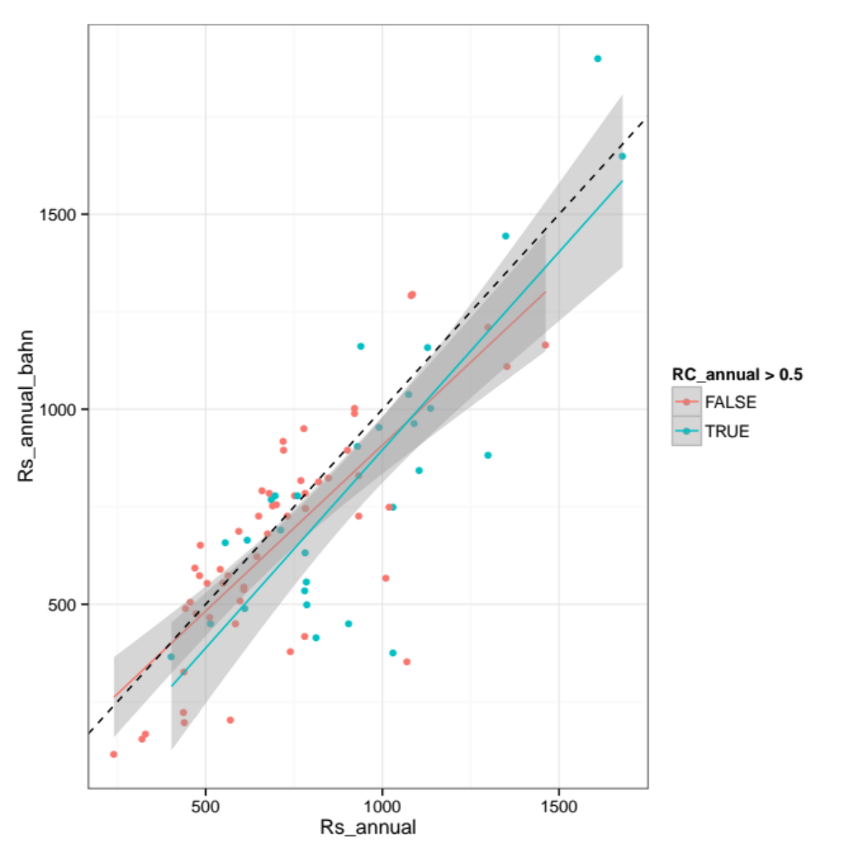

How does annual coverage affect the SR relationship?

Studies report annual SR based on measurements that may span the entire year or, more frequently, less than a year (e.g. inferring annual SR from only growing season measurements). Unsurprisingly, more coverage means a better estimate of annual SR.

Figure D. Difference between low annual coverage (8-39% of year, red), medium coverage (39-69%, green), and high coverage (69-100%, blue).
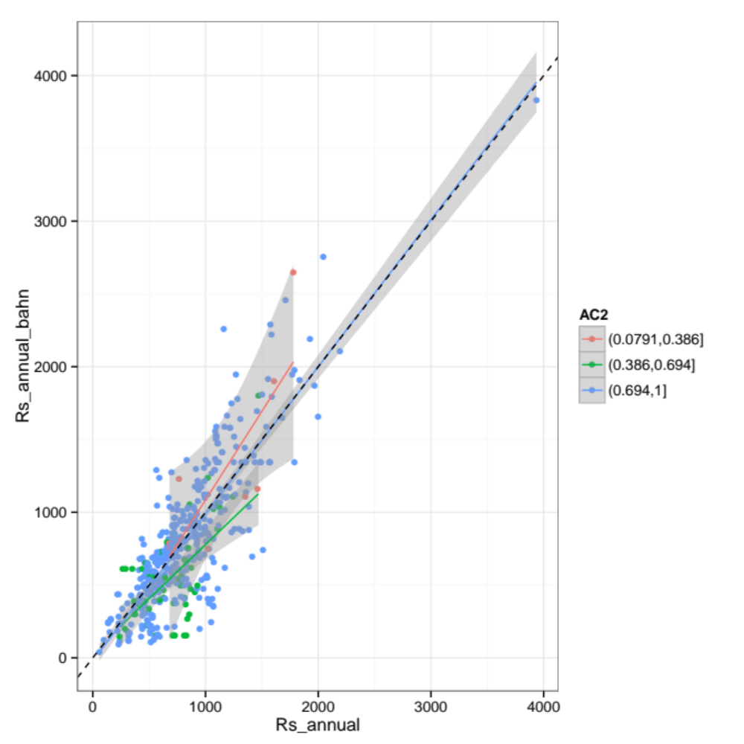

How much of the unexplained variability in Figure B is due to climate data set used?

That is, studies in the SRDB were performed in specific locations whose climates might differ from the climate data set used. To quantify this effect we look at the difference between Tair in the climate data and mean annual air temperature during the study, which is (sporadically) reported in the database. About 10% of the data have air temperatures differing by >5 °C, and this does have a significant effect.

Figure E. Effect of maximum allowed divergence between global climate data set and site-specific air temperature, when given. As we throw out data points with high divergence, R² goes up (top panel) and RSE goes down (bottom, g C m⁻² yr⁻¹).

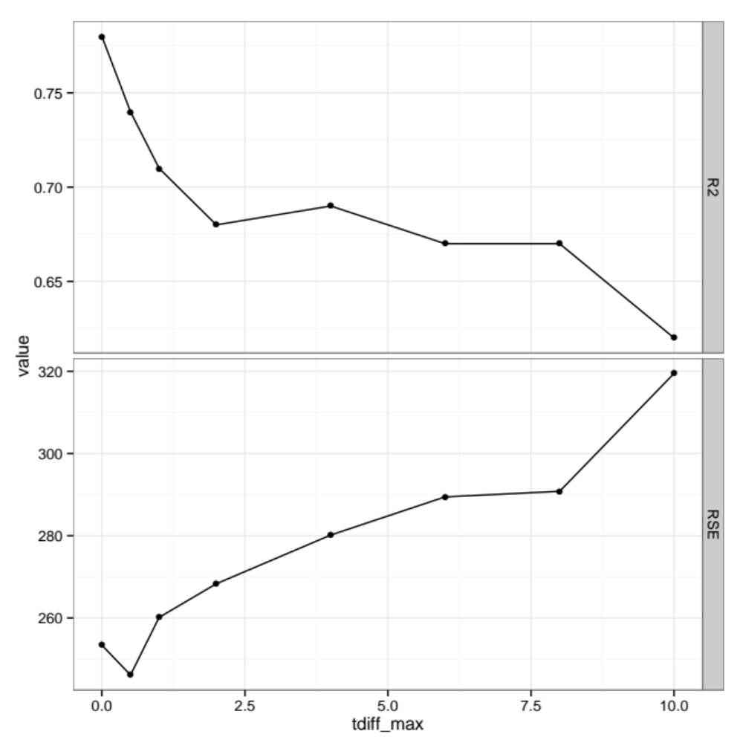

Sites with more-variable air temperatures (across the year) exhibit worse fits.

That is, the estimation of annual SR becomes poorer with greater variability in monthly air temperature.

Figure F. As Figure B, but broken into three groups by standard deviation of monthly air temperatures (°C). With higher variability, the regression significantly departs from 1:1.
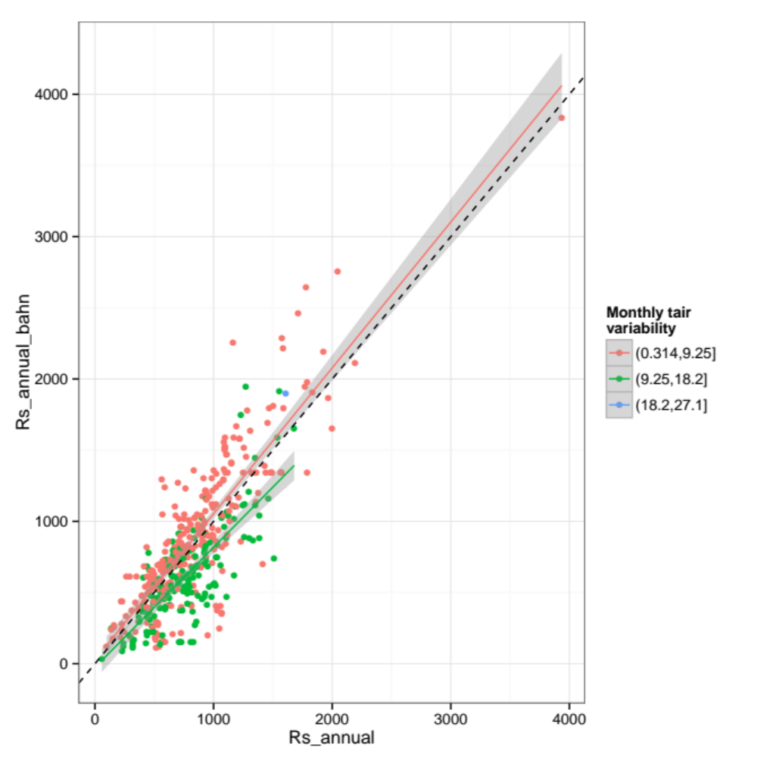

Sites with more-variable precipitation (across the year) exhibit worse fits.

As with air temperature, the estimation of annual SR becomes poorer with greater variability in monthly precipitation.

Figure G. As Figure B, but broken into three groups by standard deviation of monthly precipitation (mm). With higher variability, the regression significantly departs from 1:1.
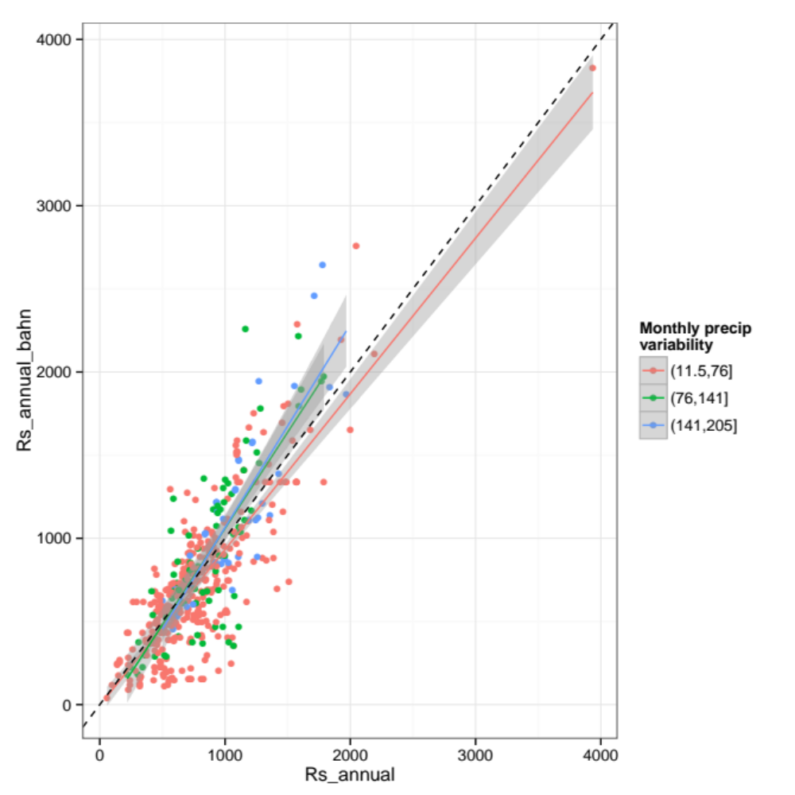

Drought (as measured by max PDSI) had no significant effect.

Estimate Std. Error t value Pr(>|t|)
(Intercept) -63.47316 33.50693 -1.894 0.0588 .
Rs_annual 1.01965 0.03666 27.816 <2e-16 ***
PDSI2(2.89,5.79] 56.01688 74.99116 0.747 0.4555
PDSI2(5.79,8.69] 192.14521 132.68222 1.448 0.1483
Rs_annual:PDSI2(2.89,5.79] -0.00149 0.08359 -0.018 0.9858
Rs_annual:PDSI2(5.79,8.69] -0.01326 0.16227 -0.082 0.9349

Figure H. As Figure B but broken into three PDSI groups.
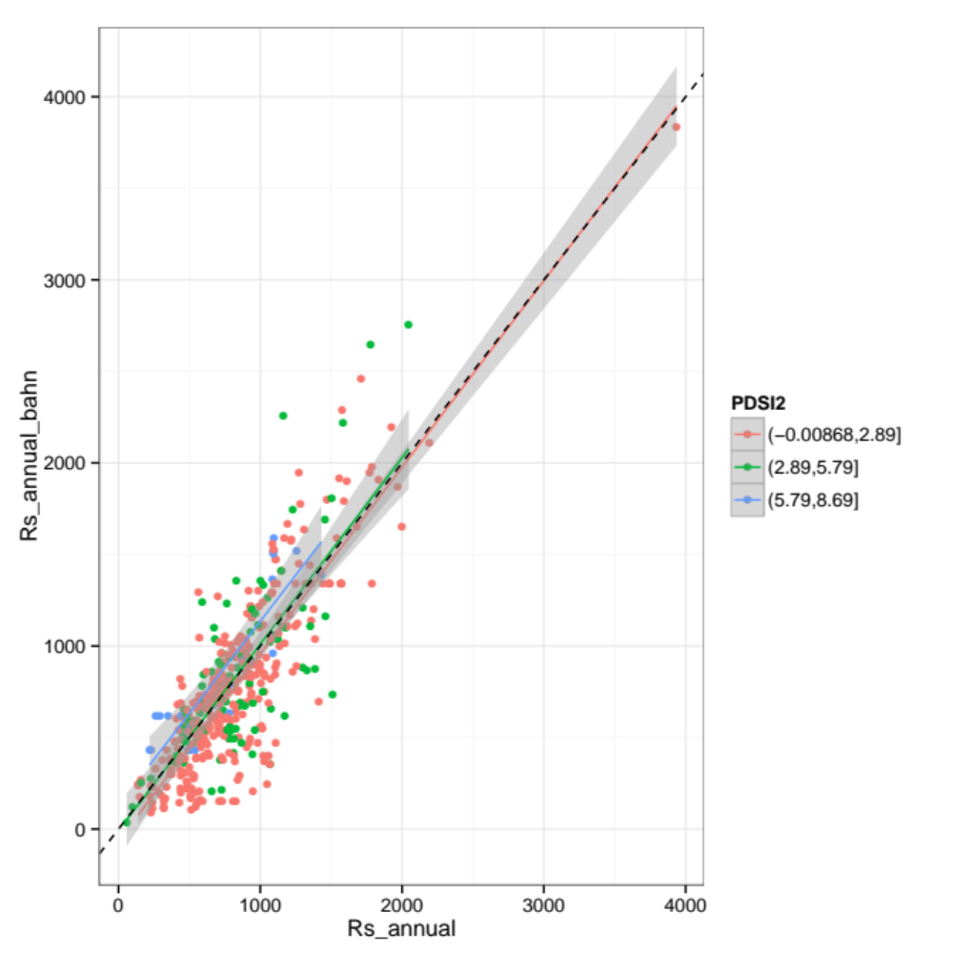

Others analyses?

